Raising a Thinking Child uses the
I-CAN-PROBLEM-SOLVE
approach.
Through this approach, children learn ways to resolve their own
common conflicts and challenges.
Raising a Thinking Child
To learn about upcoming classes or to schedule a class for your group, call
Amanda Coorough
Columbia County
608-742-9684
Amanda.coorough@wisc.edu

Help your kids get along
with family and friends by teaching them valuable
problem-solving skills!
A program for parents and
caregivers of 4-7 year-olds

The University of Wisconsin–Madison does not discriminate in its employment practices and programs and activities on a variety of bases including but not limited to: age, color, disability, national origin, race, or sex. For information on all covered bases, the names of the Title IX and Americans with Disabilities Act Coordinators, and the processes for how to file a complaint alleging discrimination, please contact the Office of Compliance, 361 Bascom Hall, 500 Lincoln Drive, Madison WI 53706, Voice 608-265-6018, (relay calls accepted); Email: uwcomplianceoffice@wisc.edu.

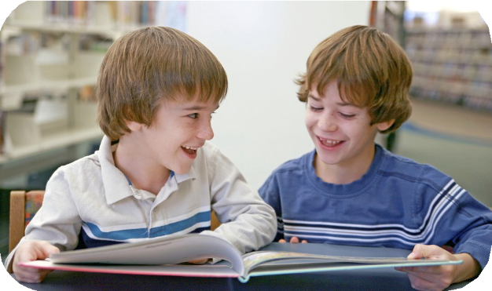
Did you know...
Are you the parent or a caregiver of a 4-7 year-old?

Are you looking for new ways to handle...
- Temper tantrums;
- Conflicts with siblings, friends, or classmates;
- Interrupting or impulsive behavior;
- Listening problems?
If so, Raising a Thinking Child
may be just right for you!
This series will help you guide your child to handle common issues through communication
and problem-solving.
Raising a Thinking Child is...
Fun
Effective Easy to learn
Children as young as four can learn to think for themselves in ways most of us never thought possible?

Through the evidence-based Raising a Thinking Child program, parents teach young children to:
Solve problems and resolve daily conflicts
Think about consequences and explore positive solutions
Consider the feelings of others
Manage common challenges independently

Raising A Thinking Child
can help shy children become more assertive. It can help impulsive children cope with frustration when things don’t go their way.

These skills can prevent and reduce behaviors that predict later problems such as violence, substance abuse, and depression.

This six-session educational series uses fun, interactive lessons to help parents/caregivers teach their kids valuable skills that can last a lifetime!

