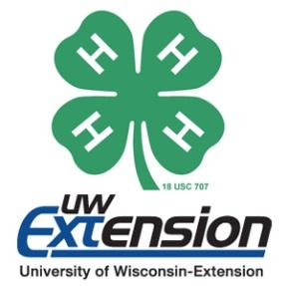
Columbia County 4-H
Award & Educational Travel Opportunity Selection Form

4-H Member’s Name
Street Address
City, State, Zip Code
E-mail Address
4-H Club Grade (at time of application)
Parent/Guardian’s Signature
By signing this form, I recommend the member for these opportunities and feel they would be a good representative of Columbia County 4-H:
4-H Club Leader’s Signature
Please rank award/educational travel opportunities in order of preference (#1 as first choice, etc.). See pages 2 and 3 of this packet or visit the 4-H website for more information and eligibility requirements. If you are not eligible, please place an X and do not include it in your preference ranking.

State 4-H & Youth Conference (June)

Chicago Daze (Summer)

Citizenship Washington Focus (June or July)

National 4-H Congress (Fall Next Year)

National 4-H Conference (April)

4-H Key Award (Fall Next Year)
Return this form with your completed cover letter and resume by October 1 to:
Columbia County UW-Extension Office
℅ 4-H Award & Educational Travel Opportunity Selection
112 E. Edgewater St., Room 212
Portage, WI 53901
Interviews will be held within the month of October. You will be notified of the specific time.

